Angela McIntyre Town Clerk
Maghull Town Hall
Hall Lane
Maghull
Merseyside L31 7BB
Date: 23rd February 2022
Our Ref:
Your Ref:
Tel: 0151 526 3705
Email: angela.mcintyre@maghull-tc.gov.uk
MAGHULL TOWN COUNCIL
Planning Services
Sefton Council
Magdalen House
30 Trinity Road
Bootle
L20 3NJ

Dear Sir/Madam,

2021 Draft Information Note: Managing and Mitigating the impact of recreation pressure on the Sefton Coast – Sefton’s Interim Approach Draft for Consultation and development management purposes
Maghull Town Council (MTC) welcomes the opportunity to comment on Sefton Council’s 2021 Draft Information Note on Managing and Mitigating the impact recreation pressure on the Sefton Coast – Sefton Interim Approach (SIA) published for public consultation ending on 25 February 2022.
The SIA and Draft Evidence Report (Version 24) - Towards a Liverpool City Region European Sites Recreation Mitigation and Avoidance Strategy (DER) were fully considered at a MTC Full Council meeting held on 2 February 2022.
MTC takes a close interest in the planning and development of Maghull and the surrounding area. It was responsible for the preparation of Maghull Neighbourhood Plan (2017-2037), which forms part of the statutory development plan.
The policies of the Neighbourhood Plan set out MTC’s commitment to ensure that community infrastructure is considered as part of the planning process. This includes provision for Open Space improvements including outdoor recreation and the enhancement of Green Corridors (Policy MAG1, AP6.8- 6.9).
MTC’s response to public consultation on SIA is set out below and is made in the context of MTC’s ongoing strategic priorities set out in the Neighbourhood Plan.

Developing a Recreation Mitigation Strategy
MTC acknowledges that the Habitat Regulations place a legal responsibility on Local Authorities to mitigate any adverse impact from planned growth on designated and protected European Sites. In the background documentation published for consultation, it is explained that Natural England (the statutory body responsible for nature conservation in England) requires that a strategic solution, in the form of a Recreation Mitigation Strategy (RMS) is prepared and implemented for the Liverpool City Region (LCR). The DER confirms that Local Authorities in the LCR are currently working in collaboration to prepare a RMS. Progress to-date on the development of an RMS is welcomed and supported by MTC.
MTC supports the principle of developing and implementing a RMS for the Liverpool City Region led by the Merseyside Environmental Advisory Service.
MTC notes that the RMS is still at an embryonic stage. The DER confirms that data to support an RMS is incomplete and at present inadequate, and is to be addressed by commissioning new surveys, in order to provide a robust evidence base.
It is anticipated that the necessary surveys will be completed in June 2022. With the evidence base provided by this survey information, an RMS will be formulated and following consultation in Spring 2023 adopted in the same year.
The timetable and programme for developing the RMS is set out in Section 11 of the DER. However, MTC wish to bring to your attention that there appear to be errors and/or inconsistencies in the chronological sequence and timeframes indicated (reference paragraph 5.54 and 11.2 of the DER). The chronology and timescales set out in Section 11 suggest that the earliest adoption date may in fact be mid 2024 as opposed to 2023.
The current position can therefore be summarised thus. The DER is a Draft document to be updated and informed by further evidence gathering before formulating and promulgating a strategic solution, a RMS. Moreover, the aims and objectives of the RMS have yet to be determined. Similarly, the governance procedures for implementation of a strategy, and the measurement and success criterion following implementation are as yet not identified.
MTC would therefore suggest that the aims and objectives of the RMS must acknowledge the Maghull Neighbourhood Plan as a development plan document and respond to Neighbourhood Plan Policy MAG1: Priorities for funding Infrastructure Projects.

2021 Draft Information Note
The initiative taken by Sefton Council in progressing an SIA is welcomed by MTC.
Nevertheless, the introduction of SIA which proposes to introduce an opt-in levy on new housing or opt- out alternative, prior to the formulation of a RMS, is considered to be premature and unjustified at this point in time for the following reasons:
- The Interim Approach is not justified in the absence of an RMS underpinned by robust evidence base;
- The RMS is still to be produced and subject to public consultation.
- The RMS is a Liverpool City Region response to the issue of mitigating and managing recreational pressures on coastal designated sites. The issues, response and solution to relieve recreational pressure on sensitive coastal areas requires a regional response and not a ‘go it alone’ initiative as proposed;
- The introduction of an opt-in levy prior to determining how funds are to be used or the ability to measures the effectiveness of any mitigation is invalid and fundamentally unsound;
- The interim approach advocated by Sefton Council does not consider Open Space improvements including outdoor recreation and the enhancement of Green Corridors (Policy MAG1, AP6.8- 6.9), which are identified in the Maghull Neighbourhood Plan.

Draft Evidence Report (DER) and Survey Data
The DER reports that there are significant evidence-base shortcomings to be resolved prior to completing the RMS. Several different visitor surveys are referred to (reference DER, paragraph 5.2 and 10.1) and were undertaken between 2009 – 2018. These surveys provide a range of information covering different years, locations and methodologies. The surveys were not designed to understand or interpret the link between housing, improved access and recreation activity at the coast. de Environmental Advisory Service.
Significantly. most of the surveys undertaken preceded the opening of Brooms Cross Road and the impact it has undoubtedly had in making the Sefton Coast more accessible to the wider urban conurbation, east of the Borough.
The DER recognises this has to be addressed and appreciates that the formulation of RMS cannot be progressed until this data is available and assessed.
MTC agrees that the RMS cannot be formulated before requisite evidence and surveys have been completed. The DER reports that this is the conclusion reached by the RMS Steering Group. The roll out of the SIA is therefore premature and itself not underpinned by a robust evidence basis.
MTC consider that the surveys to be conducted should assess the impact of improved accessibility to the Sefton Coast since Brooms Cross Road was opened in 2016.

Housing, Future Growth
The proposition in the DER is that recreational pressures on coastal areas and protected European sites derives from housing growth and that any mitigation measures shall be funded by imposing a levy on new housing completions.
The hypothesis in DER that recreation pressure is a direct consequence of housing growth in the region is false. Recreational pressures on the coast derives from the existing population and is not merely a function of new housing development. In fact, the concept that the burden of mitigation falls on new housing is an oversimplification. New housing growth does not necessarily correspond to population growth as the factors that influence housing need and provision include the rate of household formation and demographic profile of the existing population. It is not solely linked to population growth. Recreation pressures on the coast arise from health, wealth, lifestyle, more leisure hours and increased car ownership.
Moreover, (Habitat Regulations place a legal responsibility on local authorities to mitigate any adverse impact from planned growth on designated European Sites). The DER identifies that increased pressure on the coast also derives from economic activity namely the growth of Liverpool 2 and the expansion of the Liverpool John Lennon Airport. Although the Sefton Local Plan allocates 81.6 hectares of land for employment, there is no suggestion that contributions towards meeting the cost of mitigation should be sought from businesses. This suggests that there is a disproportionate burden on housing development, which is expected to fund all mitigation measures without any contribution from businesses.
Appendix 8 of the DER sets out details of intervention measures and costs for Site Access Management Measures (SAMM) and Sustainable Alternative Natural Greenspace (SANG) based on 15-year financial period with an estimated cost of circa £9.2m.
It is proposed that this cost is to be met by imposing an opt-in levy or tariff on new dwellings for schemes of 10 or more homes. A differential tariff is to be applied for new dwellings according to their location within a defined ‘Core’ and ‘Outer Zone’.
Based on housing requirements set out in emerging and adopted Local Plans, it is estimated that the potential supply of new in the City Region in both Core and Outer Zones will be 68,334 dwellings.
MTC consider that this figure is an overestimate mainly drawn from the housing provision identified from Local Plans prepared by Local Authorities. However, these plans cover different periods of time. For instance, the Local Plans adopted by Knowsley and Sefton end in 2028 and 2030 respectively, before the conclusion of the 15-year financial plan. Beyond this period, housing provision in these two Local Authority areas will be dependent on a Local Plan review, which is awaited. Wirral Council has yet to publish its Draft Local Plan and any predictions regarding housing supply have yet to be tested at Examination. Nevertheless, the potential supply of new housing in Wirral is set at 11,400 over the next 15 years.
The assumptions regarding housing growth and delivery are suspect. Consequently, if the rate of house completions falls short of the predicted levels then the expenditure costs identified in the Financial Plan will not be met.
MTC consider that placing the burden of mitigation of costs on new housing development is a disproportionate to the impact that housing development will have on recreational pressure on coastal areas. There is no evidence that recreational pressure on the coast increases in corelation to house completion rates. MTC objects to the approach taken, and on matters of detail, and particularly the mechanism for funding the cost of mitigation.

Inner Core and Outer Core Zones
The DER and SIA propose a spatial approach to recreation pressure avoidance. Two zones are identified. An inner core zone of up to 5km to European site boundaries generating an assumed 75% of coastal visits and an outer zone of >5km generating less than 25% of visits.
The Core and Outer Zones are defined on Map 1 of the SIA. Maghull and Aintree are located in the Outer Zone and the rest of the Borough in the Inner Zone.
Paragraph 2.2 of the SIA identifies that a contribution will be required for each new home, £299 per new dwelling in the Core Zone (closest to the Coast) covering Bootle, Crosby, Formby and Southport, and £63 per dwelling in the Outer Zone (away from the Coast). This includes most of Sefton East – Maghull and Aintree.
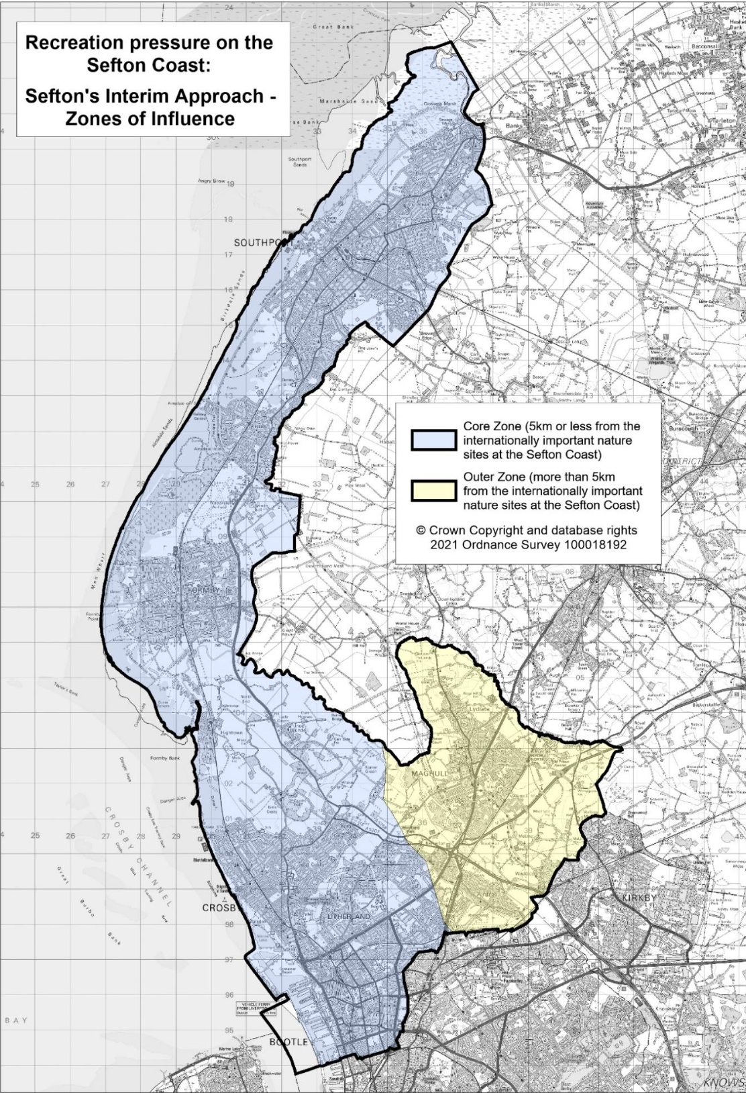

Figure 1 - Core zone and outer zone of influence, in relation to the Sefton Coast (Extract from 2021 Information Note: Managing and mitigating the impact of recreation pressure on the Sefton Coast - Sefton’s Interim Approach)
There is no explanation as to how the figure of £299 and £63 were reached. Thus, it is not possible to assess whether these differing amounts are justifiable or valid. The survey data does not support the differential tariff proposed to be applied in each zone or any other measures in advance of RMS.
The Council’s proposition is that recreation pressure on the Coast arise solely from new housing development, and therefore the cost of mitigation should be funded by financial contributions from housing developers. If this is the case, why then is a discount proposed for Maghull which accommodates the largest housing allocation in the adopted Local Plan (Site MN2.47 – Land East of Maghull, 85.8 hectares, 1400 dwellings).
The justification for the largest housing allocation on land at East of Maghull was on the basis that it would provide a sustainable urban extension. A key factor was its accessibility to the highway network and public transport connections, and therefore it is a contradiction in point to suggest that residents and new householders in Maghull are constrained in terms of accessibility, and thus less likely to visit the coast.
Moreover, the limits of the Core and Outer Zones are based on a 5km distance from European sites, with some allowance for accessibility. The allowance for accessibility does not appear to have taken into account the ease of access to the coast from Maghull and further east provided by Broom Cross Road.
Indeed, as previously referred to, the evidence base provided by surveys carried out-to-date were in the main undertaken before the opening of Broom Cross Road in 2016. If the spatial approach to recreation pressure avoidance is adhered to, then in the view of MTC this should be based on drive time (isochrone) mapping techniques as opposed to physical distance i.e <5km or > 5km.
Furthermore, the proposed differential tariff makes make no allowance for socially deprived areas such as Bootle where the level of contribution will be the same as areas in the Borough where land values are higher.
There is also no relief for previously developed sites which ought to be regarded as a priority over greenfield locations.

‘Procedural Missteps’
Section 8 of the DER sets out avoidance and mitigation options in the form of SAMMs and SANGs. The estimated costs for SAMMs are set out in Appendix 8 of the DER. Examples of potential SANG locations by Local Authority area are set out in Table 8 of DER. There are no cost details for SANGs proposed within the Core or Outer Zone as DER advises these are likely to be complex and dependent on-site specific considerations.
The approach adopted raises a number of issues.
MTC considers that the principle of preparing a detailed cost plan and mitigation measures (SAMMS) before deciding, determinising and consulting on a strategic solution (RSM) is fundamentally flawed and incorrect – ‘the cart before the horse’.
Paragraph 35 of the National Planning Policy Framework (NPPF) advises that ‘Local Plans and spatial development strategies” are to be examined to assess whether they have been prepared in accordance with legal procedural requirements and whether they are sound’. This is defined as ‘Positively Prepared, Justified, Effective and Consistent with national policy’.
Sefton Local Plan has been subject to public consultation, a process of examination and adoption. In accordance with paragraph 35 of NPPF, it has been found to be ‘Positively Prepared; Justified; Effective and consistent with national policy’.
However, the introduction of a tariff (i.e. planning obligations) on new housing at the mid -point of the adopted Local Plan has to satisfy a different set of tests set out in NPPF. Paragraph 57 of NPPF identifies that planning obligations must only be sought where they meet all of the following tests (Regulation 122(2) of the Community Infrastructure Levy Regulations 2010) namely:
- Necessary to make the development acceptable in planning terms;
- Directly related to the development;
- Fairly and reasonable related in scale and kind to the development.
The evidence and survey data demonstrating that the imposition of a tariff on new homes is necessary has not been undertaken (a). The link between new housing development and recreational pressure is not proven and, in any case, will not apply to all residential developments (b). In accordance with criterion c), planning obligations must be relevant and fairly and reasonably related to the development to be permitted, otherwise their introduction is ultra vires. There is no reference in the SIA to the above national planning policy requirements.
The tariffs proposed under SIA should not be brought in as an ad hoc measure in advance of a fully articulated and justified RSM. The DER identifies that additional surveys are to be undertaken and therefore the action proposed is not ‘Justified’. The measures proposed and costed in Appendix 8 of DER are not effective as RSM is promoted as a strategic approach for the Liverpool City Region. SIA is an interim measure promoted on a unilateral basis by one Local Authority.
All sites allocated for residential development in the Sefton Local Plan were viability tested. Allocated sites already completed or with planning permission will be exempt whilst those sites still to come forward will carry an additional burden in addition to any site-specific planning policy requirements. The MTC view is that any financial obligations to be imposed should be considered as part of the Local Plan Review process, now due five years post-adoption of the Sefton Local Plan.

In addition, MTC is concerned as regards the implications on the Maghull Neighbourhood Plan. The Neighbourhood Plan forms part of the statutory development plan. It sets out local strategic objectives which include provision for Open Space improvements including outdoor recreation and the enhancement of Green Corridors (Policy MAG1, AP6.8- 6.9). The interim approach advocated by Sefton Council does not consider the provisions of the Maghull Neighbourhood Plan. There is a heightened risk of the Neighbourhood Plan being disregarded at LCR level in the absence of acknowledgement and support from Sefton Council.

Matters of Detail
MTC consider that the costed and proposed measures set out in Table 1 of Appendix 8 have been prepared prematurely. The measures and actions proposed are put forward in advance of a strategy.
As an observation, there are relevant details omitted. For example, it is noted there is no cost provision for the accommodation of staff appointed and no provision of for equipment, training or recruitment.
We trust that above representations will be taken fully into account and that the evolution of a Strategic Approach to mitigating the impact of recreation pressure on European protected sites in preference to a unilateral initiative as proposed – SIA. MTC wishes to participate in the consultation process to achieving that objective and wishes to be notified at the appropriate stage

Yours faithfully

Prepared by Landor Planning Consultants Ltd on behalf of Maghull Town Council
PO Box 1983
Liverpool
L69 3FZ

