Hello residents of Maghull

Park Management/Play Equipment

Maghull Town Council (MTC) is pleased to announce the completion of major refurbishment works at Glenn Park and Old Hall Park, with Dodds Park also nearing completion. These parks have been significantly enhanced with the installation of new activity trails and the refurbishment of existing play equipment, making them even more enjoyable spaces for our community

In addition to the work at these parks, significant refurbishment efforts have also been completed at Balls Wood. This included the repair of swing basket, a hurricane spinner, and a two-seat junior swing, further enhancing the play experience for younger visitors.

Looking ahead, MTC is excited to share that new installation and refurbishment works are set to commence shortly at Mersey Avenue and South Meade parks. These upgrades are part of our ongoing commitment to revitalising every park in Maghull. Residents can expect more improvements in other parks as we continue our ambitious program.

We appreciate the community’s patience and support as we work to improve our green spaces. To stay updated on the latest developments and upcoming projects, please visit our website and follow our social media pages.

Together, we’re creating vibrant, safe, and welcoming parks for everyone to enjoy.

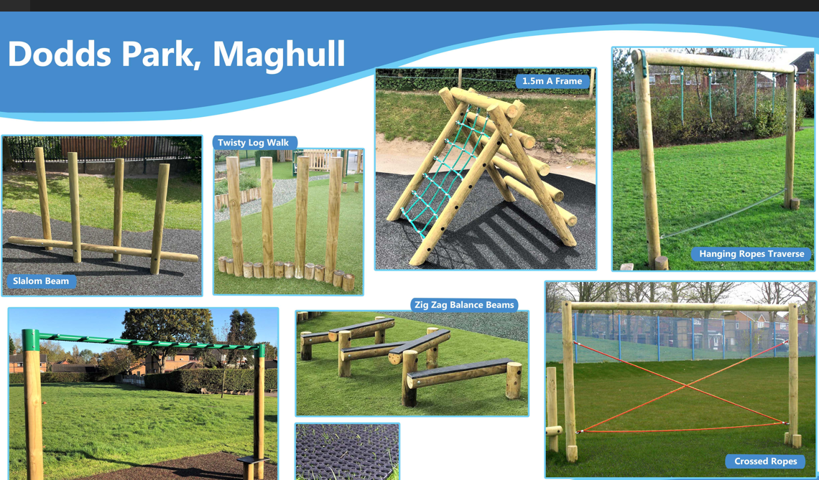
Concerns & Complaints

If residents have any concerns about the parks, play equipment, trees, or open spaces, please contact me at info@maghull-tc.gov.uk.

Derek Stephens
Facilities Manager

